**8 SCIENCE 2016**

### BIOLOGY TEST ONE

Name: ____________________ Teacher: ___________________ Mark: /52

**Percentage: %**

**SECTION A: MULTIPLE CHOICE (20 marks)**

**Select the most correct answer for each question below.**

**Please circle your answer on the multiple choice answer grid below.**

1. A B C D 11. A B C D

2. A B C D 12. A B C D

3. A B C D 13. A B C D

4. A B C D 14. A B C D

5. A B C D 15. A B C D

6. A B C D 16. A B C D

7. A B C D 17. A B C D

8. A B C D 18. A B C D

9. A B C D 19. A B C D

10. A B C D 20. A B C D

**1.** Ribosomes help the cell by:

(a) Making proteins.

(b) Making energy.

(c) Removing wastes.

(d) Storing wastes.

**2.** Which of these choices is not an organelle?

(a) Lung.

(b) Endoplasmic reticulum.

(c) Chloroplast.

(d) Mitochondria.

**3.** Look at the diagram on the right. What is shown by the labelling

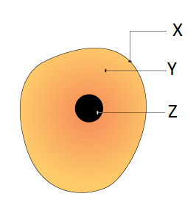 line ‘X’?

(a) Cytoplasm.

(b) Cell membrane.

(c) Nucleus.

(d) Cell wall.

**4.** Look at the diagram on the right. What is shown by the labelling

line ‘Z’?

(a) Vacuole.

(b) Cytoplasm.

(c) Nucleus.

(d) Mitochondria.

**5.** Choose the correct definition for ‘microscopic’.

(a) A scientific piece of equipment.

(b) An object made of atoms.

(c) Describes objects that can only be seen using a microscope.

(d) A type of magnifying lens.

**6.** Choose the correct definition for ‘magnified’.

(a) Made brighter.

(b) Made clear.

(c) Made smaller.

(d) Made bigger.

**7.** Choose the correct definition for ‘image’.

(a) A photo of a specimen.

(b) What is seen using the microscope.

(c) An inverted specimen.

(d) The object being looked at through a microscope.

**8.** Choose the correct definition for ‘specimen’.

(a) The slide with film.

(b) The object being looked at through a microscope.

(c) Plant or animal cells.

(d) What is seen using the microscope.

**9.** What is the job of the cell membrane?

(a) To control what substances to into and out of the cell.

(b) To give a plant cell its shape.

(c) To control what happens inside the cell.

(d) To make energy for the cell.

**10.** When a dead plant or animal is cut apart to be studied, this is called a:

(a) Biology.

(b) Butchery.

(c) Dissection.

(d) Intersection.

**11.** As the magnification of a microscope increases, then you can see:

(a) More of the specimen.

(b) Less of the specimen.

(c) More intensity.

(d) Less intensity.

**12.** What cell feature is responsible for powering the cell?

(a) Endoplasmic reticulum.

(b) Mitochondria.

(c) Ribosomes.

(d) Nucleus.

**13.** The amount of the specimen you can see through a microscope is called the:

(a) Field of view.

(b) Magnification.

(c) Illumination.

(d) Image.

**14.** The rigid part that surrounds a plant cell is called:

(a) Chloroplast.

(b) Cell wall.

(c) Cell membrane.

(d) Control centre.

**15.** The plant cell structure where photosynthesis takes place is called:

(a) Chloroplast.

(b) Vacuole.

(c) Cytoplasm.

(d) Green plant.

**16.** 6 millimetres is made up of how many micrometres?

(a) 0.6

(b) 6000

(c) 60

(d) 600

**17.** 8000 micrometres is made up of how many millimetres?

(a) 0.008

(b) 0.08

(c) 80

(d) 8

**18.** Which of the following organelles would be present in large numbers of cells that require a lot

of energy?

(a) Ribosomes.

(b) Nucleus.

(c) Mitochondria.

(d) Endoplasmic reticulum.

**19.** Name the part of animal cells that is a watery jelly-like liquid.

(a) Chlorophyll.

(b) Chloroplast.

(c) Cytoplasm.

(d) Plasma.

**20.** Select the incorrect statement.

(a) The coarse focus knob moves the microscope tube up and down.

(b) The stage clips hold the slide in place on the stage.

(c) The objective lens is the part of the microscope you look through.

(d) The fine focus knob is used to make fine adjustments on the focus.

**SECTION B: SHORT ANSWER (32 marks)**

**1.** Label the diagram of the animal cell below. (4 marks)

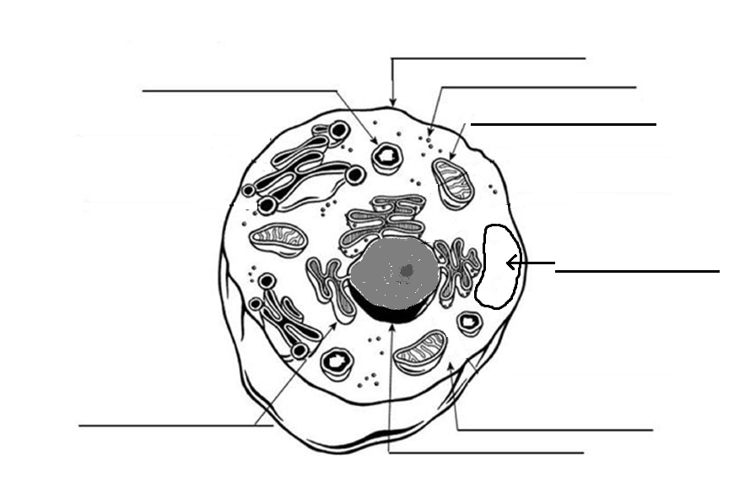

**2.** Label the diagram of the plant cell below. (4.5 marks)

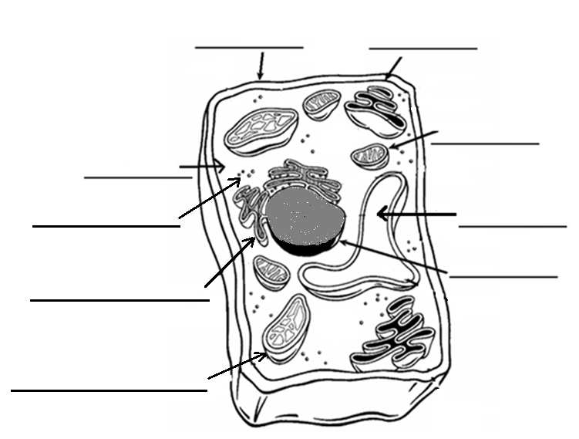

**3.** Explain three main difference between an animal cell and a plant cell. Write in full sentences. (3 marks)

_____________________________________________________________________________________

_____________________________________________________________________________________

_____________________________________________________________________________________

_____________________________________________________________________________________

_____________________________________________________________________________________

_____________________________________________________________________________________

_____________________________________________________________________________________

**4.** Write a definition for the word ‘organelle’. (2 marks)

_____________________________________________________________________________________

_____________________________________________________________________________________

**5.** Label the diagram of the microscope below. (4.5 marks)

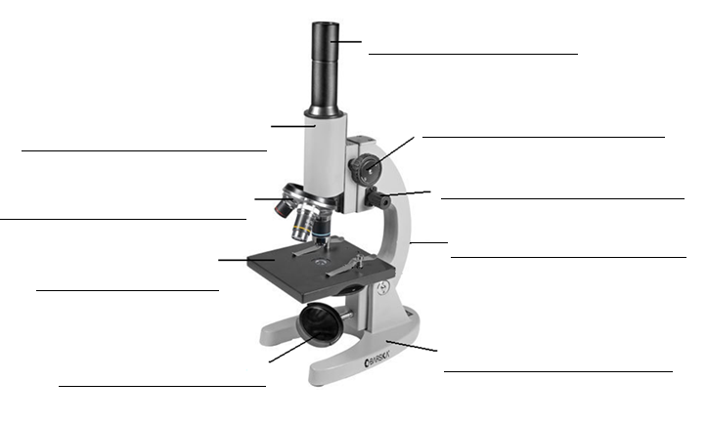

**6.** Fill in the missing words. (2 marks)

There are three __________________________ lenses.

The three magnifications are x_______, x_______ and x_______.

**7.** Fill in the table below. (5 marks)

|  |  |
| --- | --- |
| **Organelle** | **Function** |
| Mitochondria |  |
|  | Organelles that move materials through the cell. |
| Nucleus |  |
|  | Organelles that remove waste from the cell. |
| Chloroplast |  |

**8.** The things you look at under the microscopes are so small so cm or mm are not used.

State the unit of measurement used to look at things under a light microscope and the symbol

for the unit of measurement. (1 mark)

_____________________________________________________________________________________

**9.** Describe how you would safely carry a microscope. (2 marks)

_____________________________________________________________________________________

_____________________________________________________________________________________

_____________________________________________________________________________________

**10.** Circle either true or false for the following statements. (4 marks)

There are only two types of cells. True False

You can see most cells without a microscope. True False

Plants have organelles that animals do not. True False

The higher the microscope magnification, the smaller True False

the microscope field of view will be.